Objectives:

* Using the try and catch statement with Exceptions
* **6 class exercises on this document each worth 16.6%**

An **exception** is an object that is generated as the result of an error or an unexpected event. To prevent exceptions from crashing your program, you must write code that detects and handles them.

Create a project and name the project **WK03Ch11**

**Try and catch statements reading a file**

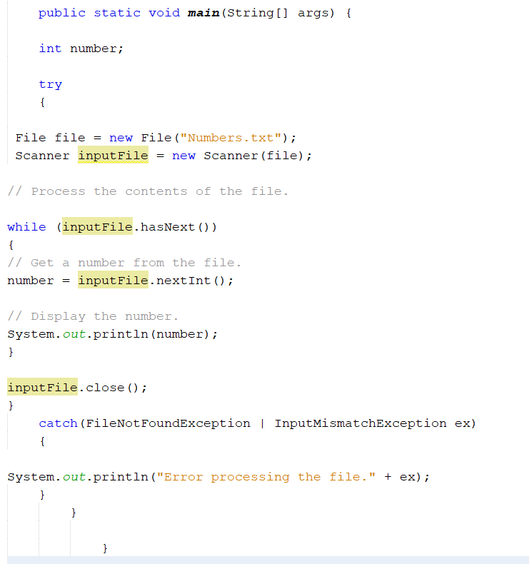

**Try and catch statements sum numbers in a file**

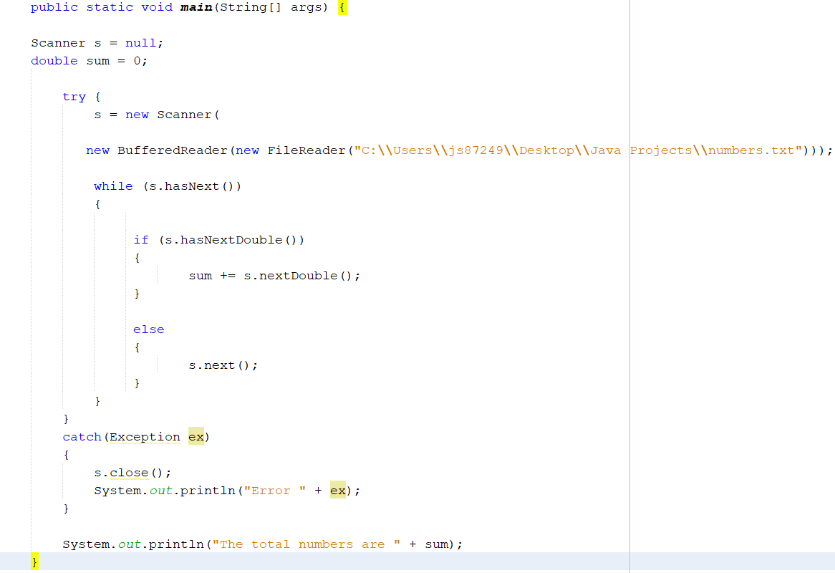

1. Calling a frame from another or 2nd frame JFrame

Type in the following code

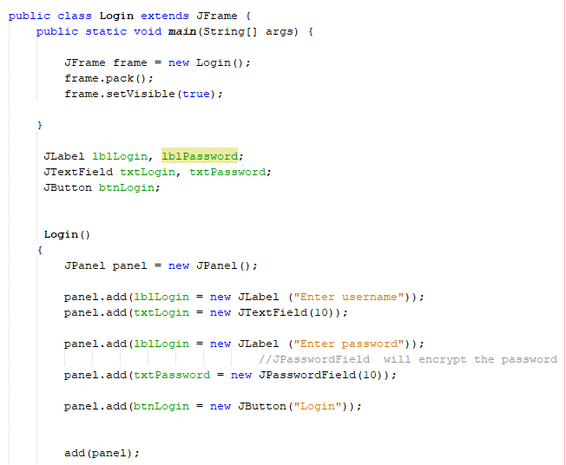

Proceed to the next page….

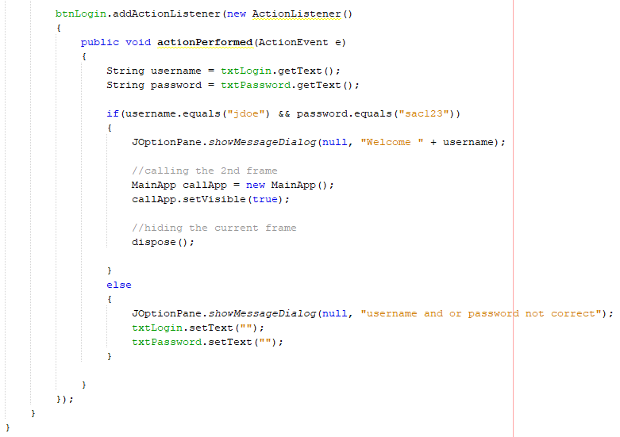

Create the 2nd frame

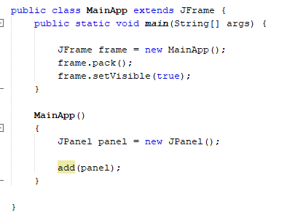

Type in the rest of the code on the next page for the MainApp class

*Declaring variables and adding the panel*

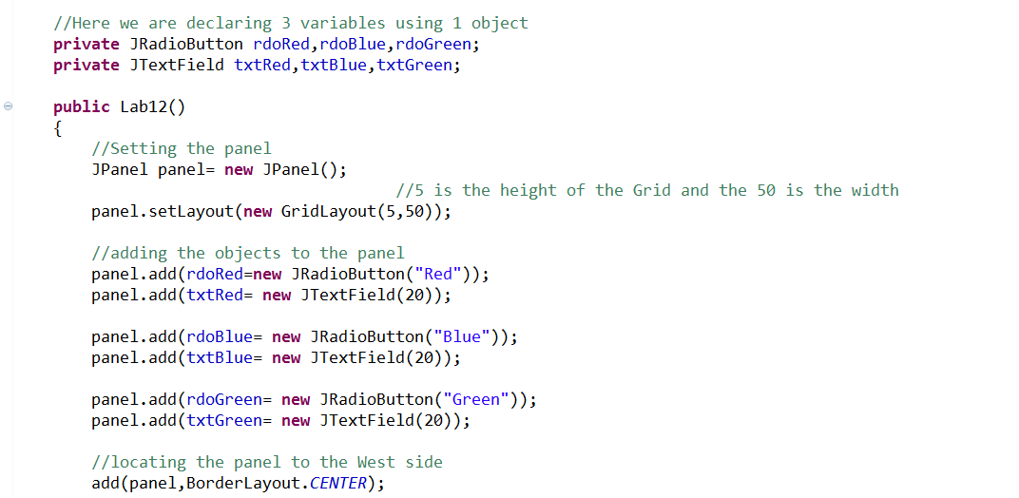

*Grouping Buttons and applying shortcut keys (To use them hold down your ALT key and then the assigned key)*

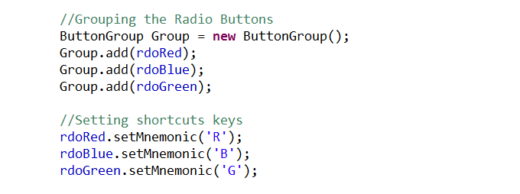

*Adding the Action Listeners so the program can listen to events*

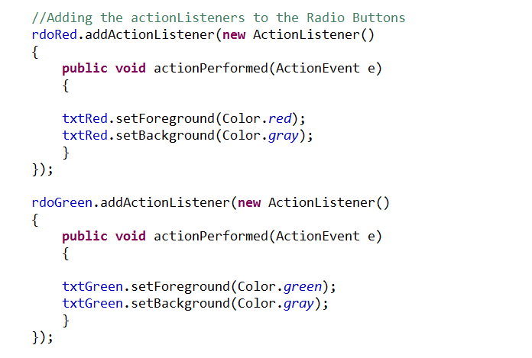

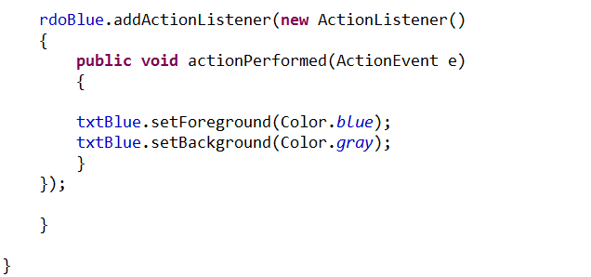

For the check Box we have to place a condition if it is check or not

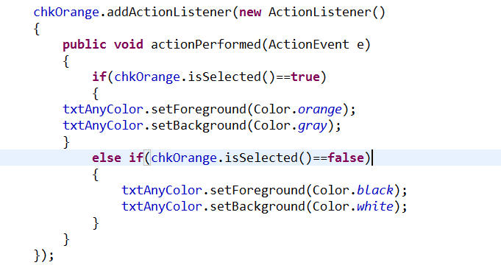

Example of the Combo Box

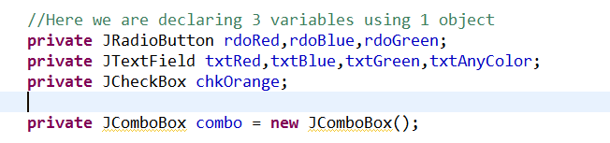

Adding the Combo Box to the panel

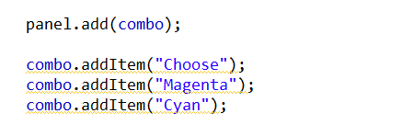

Adding the Listener and applying the condition using the Index

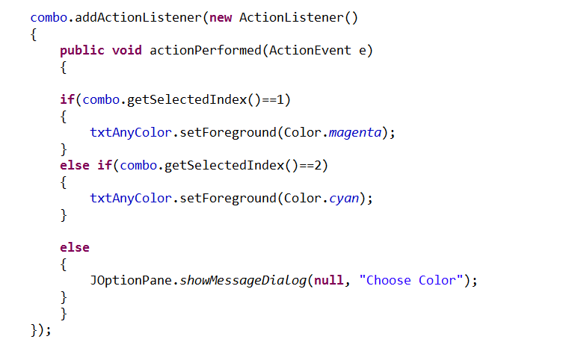

1. Create a class and name the class **WK03Class1,** Bad Array that will produce an error

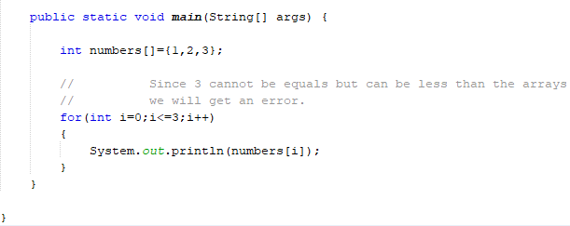

Error

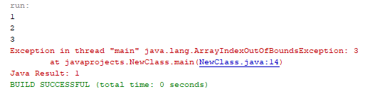

1. Create a new class and name the class **WK03Class2,** Using the try and catch statement

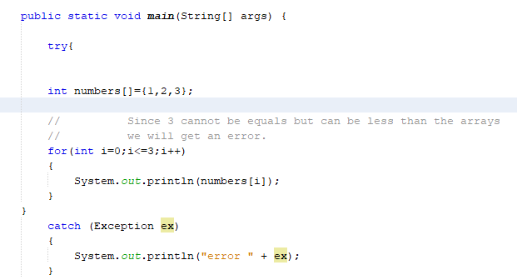

Error, but does not break

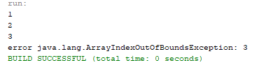

1. Create a new class and name the class **WK03Class3,** finding a file using a try and catch statement, note: be sure to create a text file named *GoodFile* in the build directory, this is the default directory where files can be located.

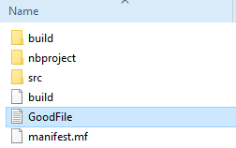

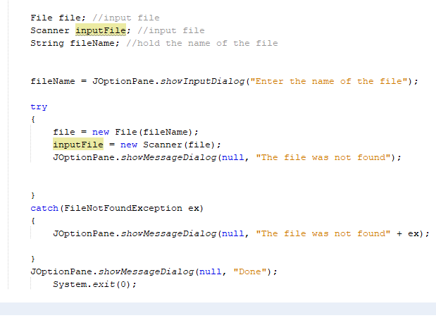

Enter the name of the file

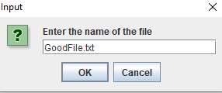

1. Create a new class and name it SalesReport then download the **SalesData** text file from Module #3 and place it into the default directory (see picture #3) for references.

Then type in the following code, the code will search for the text file and count the number of months, calculate the total and average from the text file.

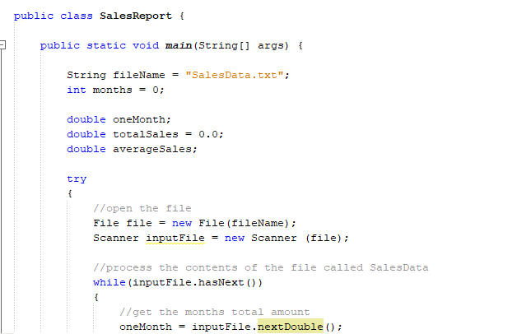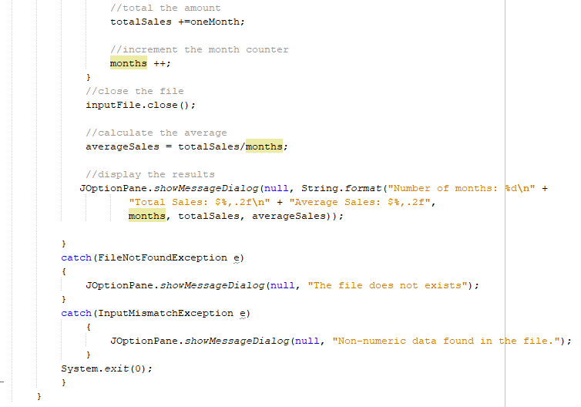

Now for the SalesData text file insert the letters ABC which will execute the second catch statement

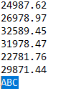

Output

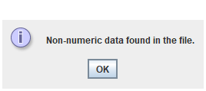

1. Create a new Class and name it **InputSalesReport** that will sum and average the sales report if the report does exist, however, if not found then create the *salesData* report with the following numbers stated above. We will be using multiple try and catch statements and allow File class to point to a directory of our own. We will also use the FileWriter class to create and write to a new file. *Please see next page for the code:*

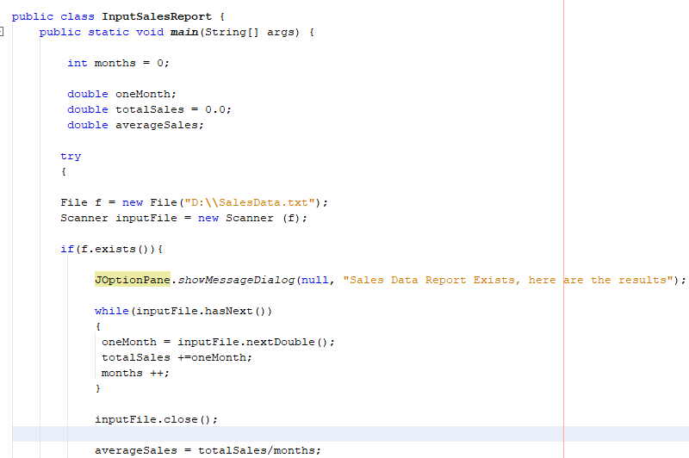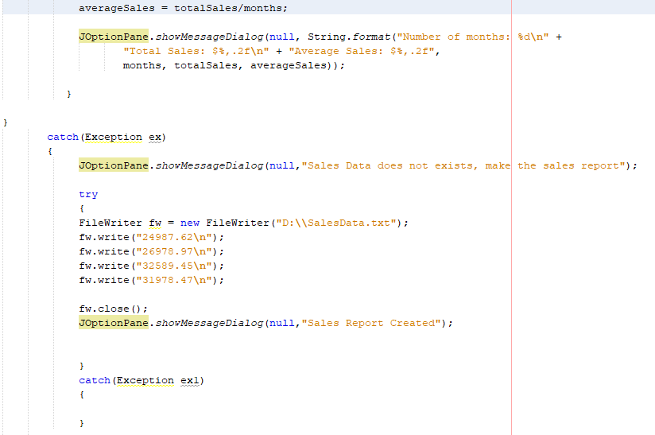

**Class Exercise #1:**

For step #3 output the numbers from the array into a text file and then read have the program be able to read the numbers from the text file

**#1 print screen your write below here**

**#1 print screen your read below here**

**#2 open the text file and print screen below**

**Copy and paste your code below here**

**Class Exercise #2:**

For step #4 the file input program, if the file *GoodFile* has been found then use a **File** **Writer** class to input the following message into the file, input >> “The file has been found, thank you”

**#3 print screen your results below here**

**Copy and paste your code below here**

**Class Exercise #3:**

For step #5, create GUI app that will perform the same algorithm as shown on step #5. Be sure to include a JLabel, JTextField and a JButton. The JTextField is where the user will enter the name of the file, in our case SalesData text file.

**#4 print screen your results below here**

**Copy and paste your code below here**

**Class Exercise #4:**

For Step #1 the login app, create a JButton on the 2nd frame and name it (EXIT), when the button object is clicked call or switch it to go to the 1st Frame (login app).

**#5 print screen your results below here**

**Copy and paste your code below here**

**Class Exercise #5:**

Turn to page 755 and complete Algorithm Workbench #1

**#6 print screen your results below here**

**Copy and paste your code below here**

**Class Exercise #6:**

Turn to page 757 and complete Programming Challenge #1

**#7 print screen your results below here**

**Copy and paste your code below here**

**Submit this document to Module 3 Class Exercise #3**